**Introduction to the Course**

In this course, we'll saw why ethical hacking is a powerful element of a comprehensive security plan. I had explored today's threat landscape, and dissected top attack vectors and compared motives for attacks. We did discover the cyber kill chain and compare the differences between white, grey, and black hat hackers. I explored policies that help enforce the security objectives of the organization. And finally, I got explained the importance of structured ethical hacking in an organization. This course is part of the ethical hacking series.

**Learning objectives**

* Today's threat landscape
* Managing incidents
* Creating security policies
* Protecting data
* The COBIT framework
* Conducting penetration testing

**Screenshots**

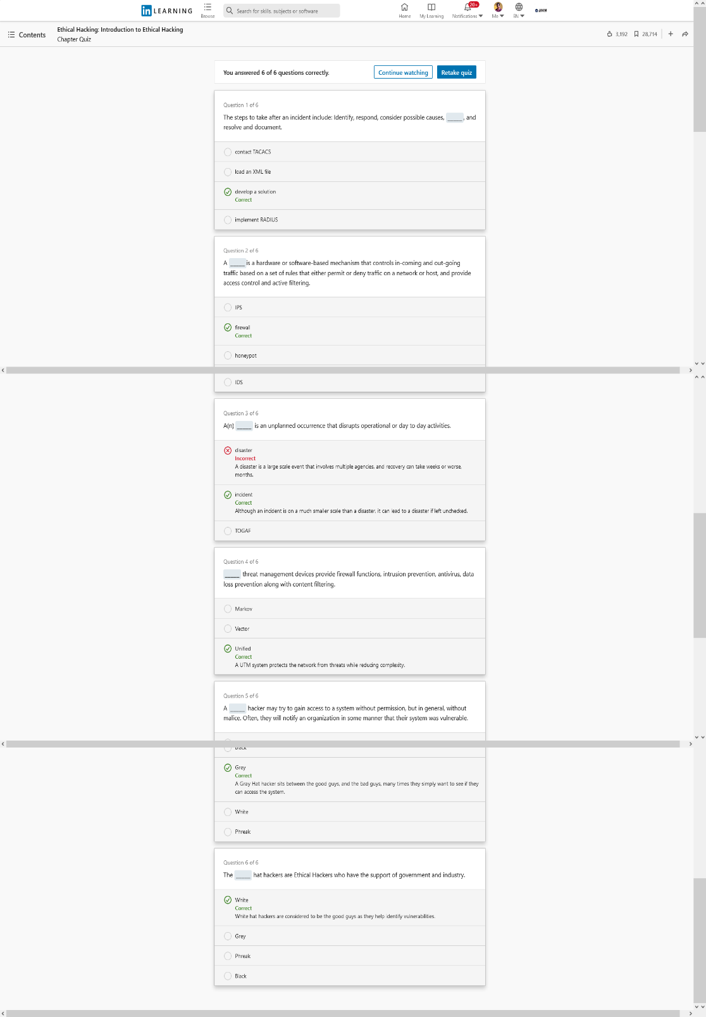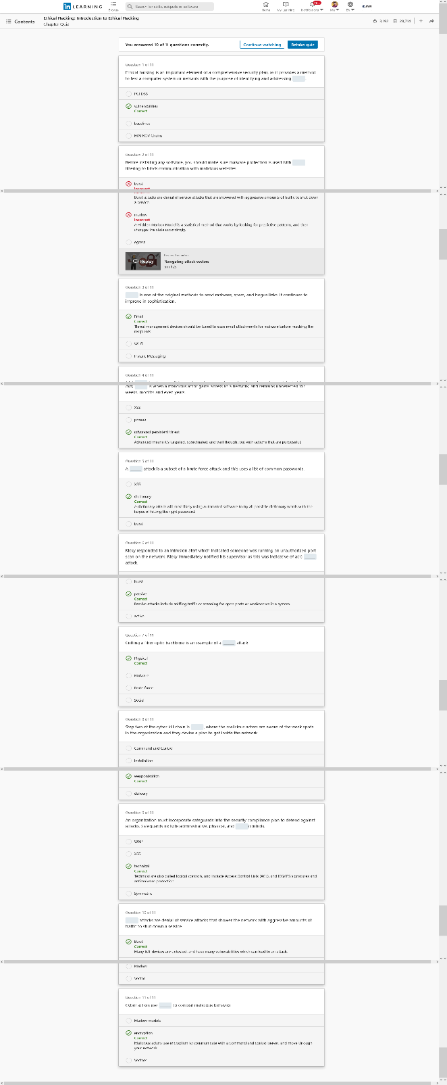

**Fig: Section 01**